7.1 FindBugs Integration with Jenkins

This section will guide you to:

* Integrate and configure FindBugs with Jenkins.

This guide has four subsections, namely:

7.1.1 Login to Jenkins

7.1.2 Create a Maven job

7.1.3 Install FindBugs plugin

7.1.4 Pushing code to GitHub repositories

**Step 7.1.1:** Login to Jenkins

* Open your browser and navigate to **localhost:8081**
* Provide your username and password and click on **Login.**

**Step 7.1.2:** Create a Maven job

* Go to Jenkins Dashboard -> New Item -> Choose name for the Maven Project (e.g. MyFirstMavenExample) and select **Maven Project** as the job type.

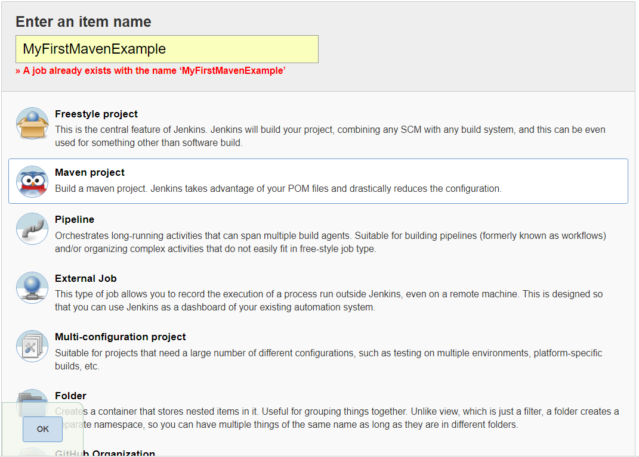

* On Configure Page, set the following:

1. Discard Old builds
   * 1. Days to keep builds: 1
     2. Max builds to keep: 5

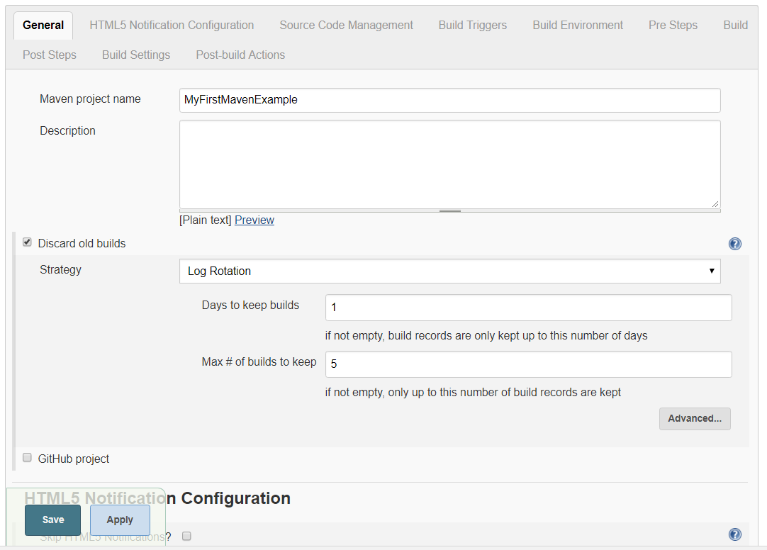

2) JDK (to be used for this project) Java-1.8

3) Build -> Advanced -> Enable the following:

- Resolve dependencies during Pom parsing

- Use custom workspace (add path of the folder containing pom.xml)

-Goals & Options = **clean install findbugs:findbugs**

* Apply & Save

**Step 7.1.3:** Install FindBugs plugin

* Navigate to **Manage Jenkins > Manage Plugins > Available** to install FindBugs plugin.
* Restart Jenkins
* Build the job

**Step 7.1.4:** Push the code to your GitHub repositories

* Open your command prompt and navigate to the folder where you have created your files.

**cd <folder path>**

* Initialize your repository using the following command:

**git init**

* Add all the files to your Git repository using the following command:

**git add .**

* Commit the changes using the following command:

**git commit . -m “Changes have been committed.”**

* Push the files to the folder you initially created using the following command:

**git push -u origin master**